Troop ONE
CAMP SCHEDULE
February 23 - 25

Prior to Campout
- $15/Person (Max $45) – Cash at Campout or Pay by Website: https://www.tsg1.org/donations-sponsorship/
  - Supports purchase of materials, food, snacks, and maintenance of equipment
- Register for Troops of St. George
  - https://www.tsg1.org/register

Links
- https://www.tsg1.org/1st-camp-what-do-i-need-2/
- https://www.tsg1.org/want-to-join-the-tsg/
- https://www.tsg1.org/waiver-of-liability-form/
- https://www.tsg1.org/camp-waiver-of-liability-form-captain-use/

FRIDAY

- 4:00pm +
  - Arrival
  - Sign-In
  - Set tents, prepare fire pit, collect wood, erect flag mast, prepare kitchen, water setup, latrines, etc.
- 5:30pm
  - Start fire (Any Father/Son)
- 6:00pm
  - Angelus
- 8:00pm
  - Campfire Orientation
  - (Dinner - NOT provided - on your own – best on the way)
- 9:00pm
  - Rosary
- 10:00pm
  - Lights out (Cadets to quarters / QUIET)

SATURDAY

- 6:45am
  - Reveille
- 7:15am
  - Morning Prayers
    - Our Father, Hail Mary, Glory Be, St. George (Pray for Us!), Parati Semper
  - Raise the Colors - Pledge of Allegiance
“I pledge allegiance to the flag of the United States of America and to the Republic for which it stands, one Nation under God, indivisible, with liberty and justice for all.”
- 7:30am
  - Breakfast (All Fathers & Cadets to assist – prep / cleanup)
    - Designated Dad breaks off and preps Breakfast
- 8:30am
  - Physical Training (e.g., Jog, Push-ups, Sit-ups, Jumping Jacks, etc.)
    - After Prayer & Flag Ceremony
- 9:00am
  - Knife Safety
  - Bushcraft Tent Construction
- 11:00am
  - Basic Training Station Rotation (Knife Safety, Knots, Fire Craft, Water Purification, Cardinal Directions)
- 12:00pm
  - Angelus
  - Hike
  - Break for lunch (sandwich, chips)
    - Designated Dad breaks off and preps Lunch
- 1:00pm
  - Cut Trees with Chainsaw
- 2:00pm
  - Tractor Familiarization
  - Side by Side (4x4) Familiarization
- 3:00pm
  - Free Time
    - Practice Basics, Fish, Explore, Capture Bugs, Climb Trees, etc.Bow & Arrow Construction
- 4:00pm
  - Divine Mercy Chaplet
  - Team Building Events
    - Games: Kickball, Dodgeball, Ultimate Fresbie/Football, Field Foosball, etc
- 5:00pm
  - Dinner
    - Designated Dad breaks off and preps Dinner
- 6:00pm
  - Angelus
- 7:23pm (Sunset Time)
  - Lowering of the Colors
- 8:00pm
  - Virtue Talk
  - Campfire Saint (Kids Favorite Saint Share)
- 8:30pm
  - Campfire Rosary
  - Ask Dad’s Anything
- 10:00pm
  - Lights out

GENERAL FRIDAY EVENING CAMP – BRIEFING AT CAMPFIRE:
Safety:
- Snakes: Pay Attention! Use extreme caution when lifting logs and rocks!
- Watch out for poison ivy (vines w/out leaves can still be a problem)
- Fire: only seniors to feed fire with permission – sticks on fire stay in fire (all seniors to monitor juniors) – no trash
- Knifes/axes/hatchets: walking with knife open – blood circle –(No knife throwing)
- Emergencies: Self-aid, Buddy-aid, Hospital (Location & Phone Numbers)
  - 3 seniors rule (1 to stay with injured, 1 to seek help)
- 2-men rule (if the cadet is not yours, go with another dad)
- 3 seniors rule (Safety protocol - 1 to stay with injured, 1 to seek help)
- Latrines at night: with adult for latrines, alone behind tent ok for light duty
- If you must leave camp area (seniors: it is a privilege that can be revoked), let an officer know and agree on a return
- Time – check posted schedule
Neatness:
- LEAVE NO TRACE: pick up trash, especially if yours, but any trash you see
- Keep your tent area and fire pit area neat
- Keep track of your stuff. Please, no lost & found. Use marker.
- Common problem: “a” mess kit is not necessarily “your” mess kit. If something was borrowed, clean it and return it.
- Latrines:
  - Cadets latrine vs. adults latrine
  - #2 only, #1 is for the trees
  - Sawdust to help control odors
  - Clean up behind yourself if unable…
  - Be responsible and courteous - if getting thin on TP… take care of it
General:
- Politeness: yes Sir, no Sir. Do not arrive or depart without saluting your officers
- Do not interrupt adults unless someone is, hurt, bleeding or something is on fire
- Kindness and Charity first!
- Any adult can give push-ups
- Any adult can confiscate a knife and give it to the cadet’s Dad (after 1 warning if light offense)
- Have fun! “A Saint who’s sad is a sad Saint”
Standard Campout Reminders
- DADS SIGN THE WAIVER UPON ARRIVAL AT CAMP
- Eat on the way to the camp location or pack some prepared food to eat there
  - No Dinner Supplied on Friday nights (other than S’Mores)
- If you cannot make it, be sure to connect with another dad or myself to send whatever supplies you need to in advance.
- Check the weather and be prepared
Thing to bring for this campout
- Fishing gear
- High-top boots if you have them (Snake Country)
- Long pants for sure
- Desire to have fun

CAMPSITE LOCATION:
2315 (Vz) County Road 3507
Wills Point, TX 75169
- Mater Dei Latin Mass Parish: 2030 E State Hwy 356, Irving, TX 75060
- Get on TX-12 Loop S from E 6th St and S Loop 12/S Walton Walker Blvd
  - 3 min (0.7 mi)
- Take I-30 E, US-80 E and I-20 E to FM2965 N in Kaufman County. Take exit 512 from I-20 E
  - 50 min (53.9 mi)
- Continue on FM2965 N. Take US-80 E to Co Rd 3507 in Van Zandt County
  - 24 min (17.9 mi)
- Arrive: 2315 (Vz) County Rd 3507, Wills Point, TX 75169

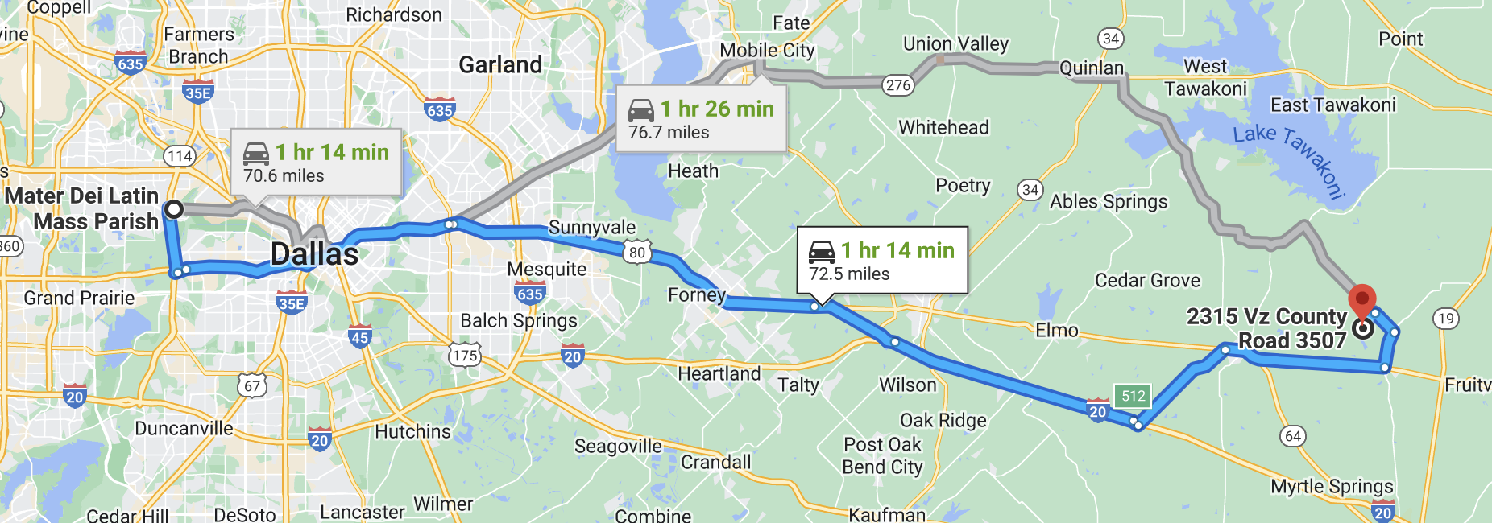
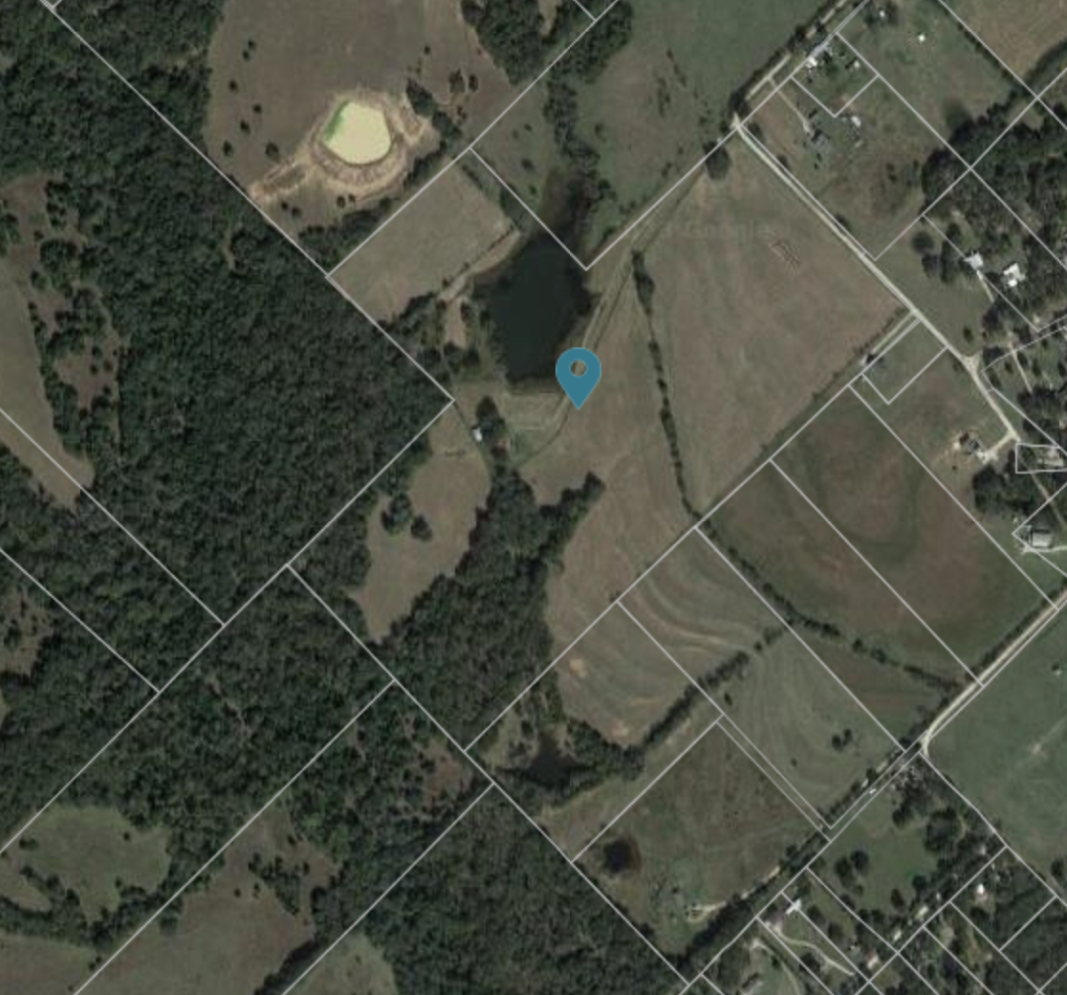
CLOSEST HOSPITAL

- (20 Min) Van Zandt Regional Hospital
  - 707 N Waldrip St, Grand Saline, TX 75140
  - +1 903-913-6300
- Campout: 2315 Vz County Rd 3507, Wills Point, TX 75169
  - Head northwest on Co Rd 3507 toward Co Rd 3511
  - 0.8 mi
- Turn right onto FM1395 S
  - 1.3 mi
- Turn right onto FM 859 S
  - 1.9 mi
- Turn left onto US-80 E/E Pine St
  - Continue to follow US-80 E
  - 9.8 mi
- Turn left onto N Waldrip St
  - 0.4 mi
- Turn left onto W Wolfe St
  - Destination will be on the right
  - 315 ft
- Van Zandt Reg'l Hospital
  - 707 N Waldrip St, Grand Saline, TX 75140

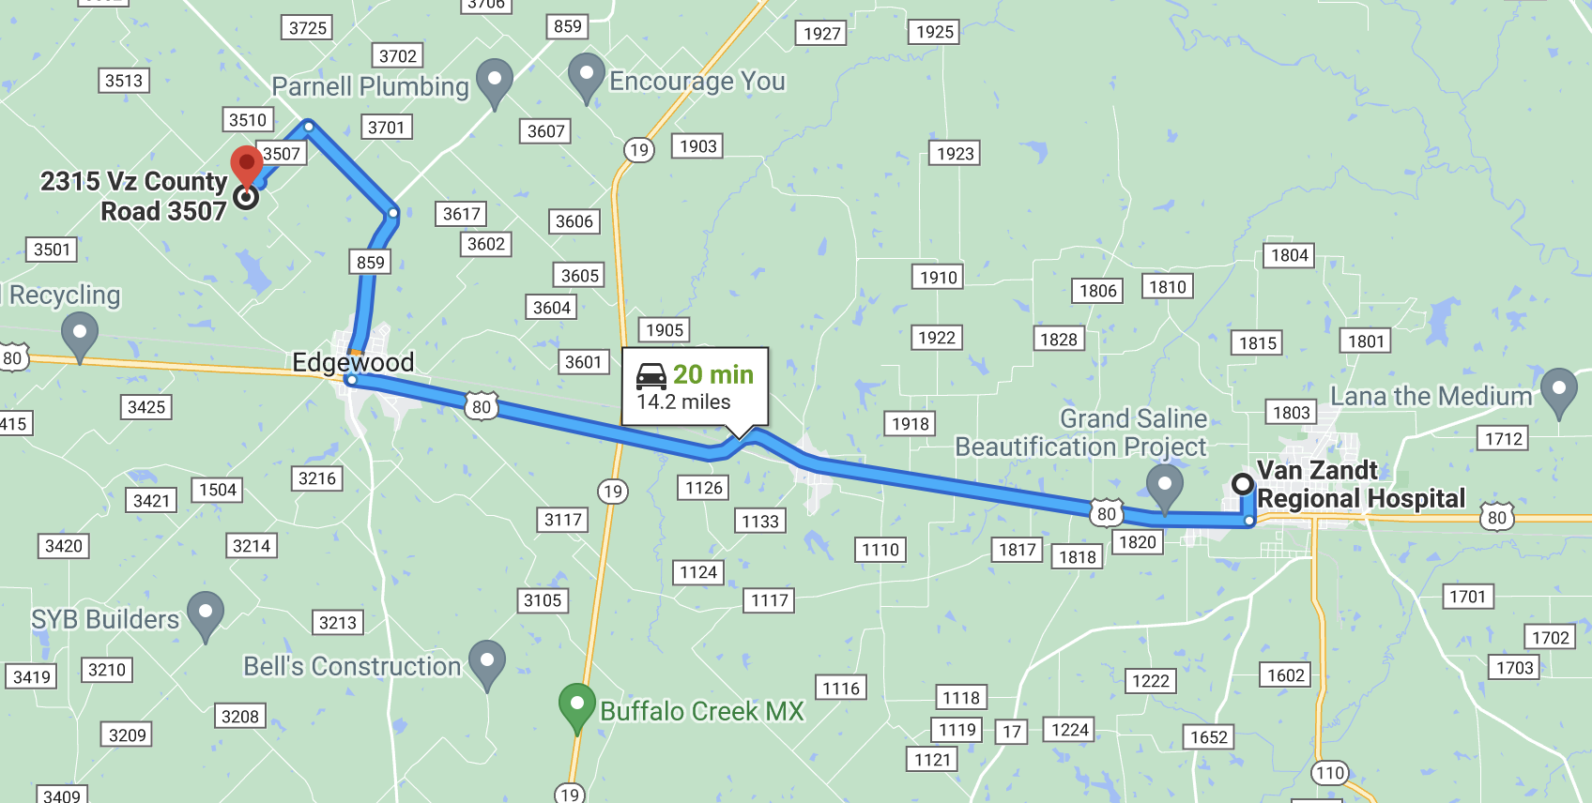

OTHER HOSPITALS

- (45 Min) UT Health Quitman
  - 117 N Winnsboro St, Quitman, TX 75783
  - +1 903-763-6300

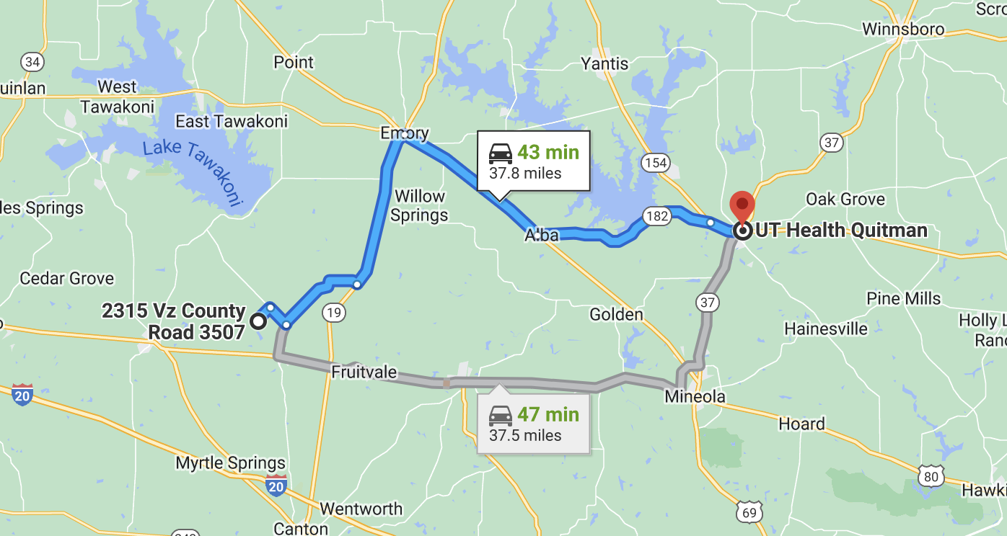

- (45 Min) CHRISTUS Mother Frances Hospital - Sulphur Springs
  - 115 Airport Rd, Sulphur Springs, TX 75482
  - +1 903-885-7671

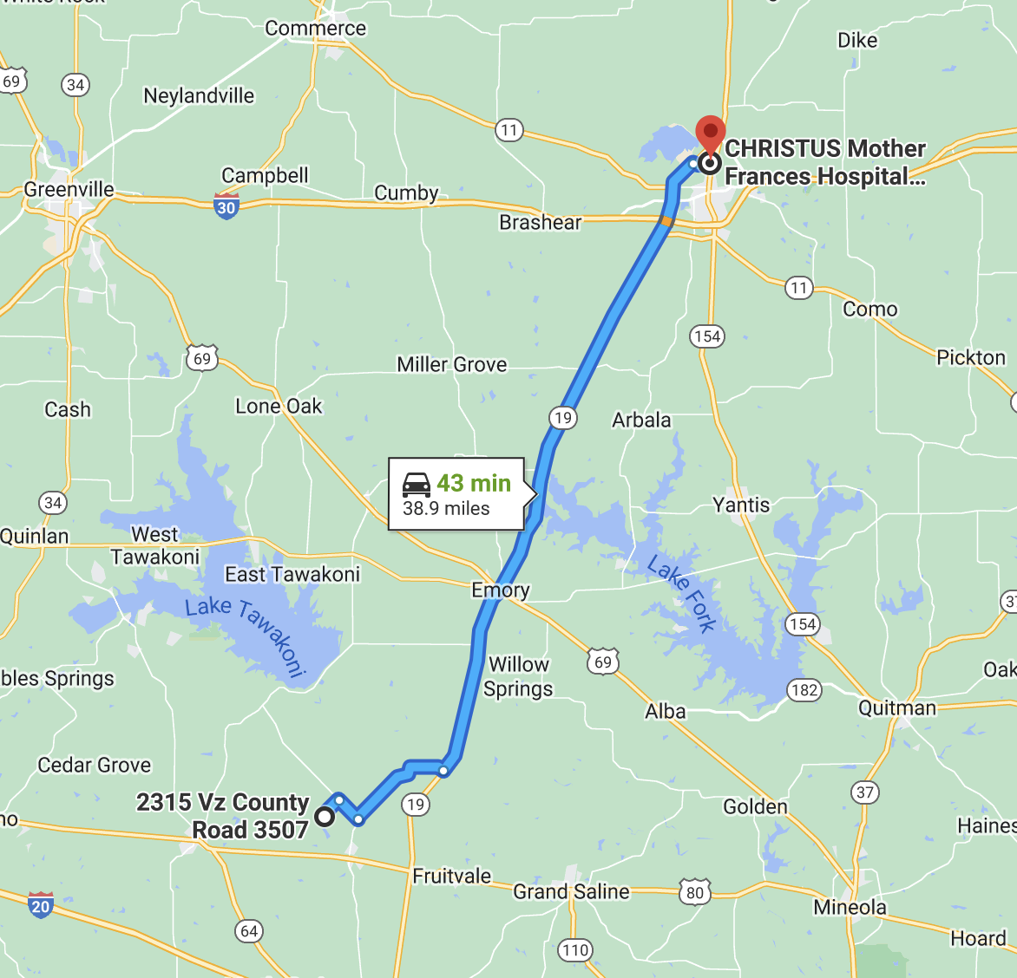

Forms

- Waiver of Liability Form – Registration
  - https://www.tsg1.org/waiver-of-liability-form/

- Camp Waiver of Liability Form – Captain use
  - https://www.dropbox.com/s/zzisxz2n0gt3fom/2015-12-02-TSG-Waiver-of-Liability-Signature-Page-TSG-15.04.pdf?dl=0

- Chaperone Form

https://www.tsg1.org/chaperone-form/

